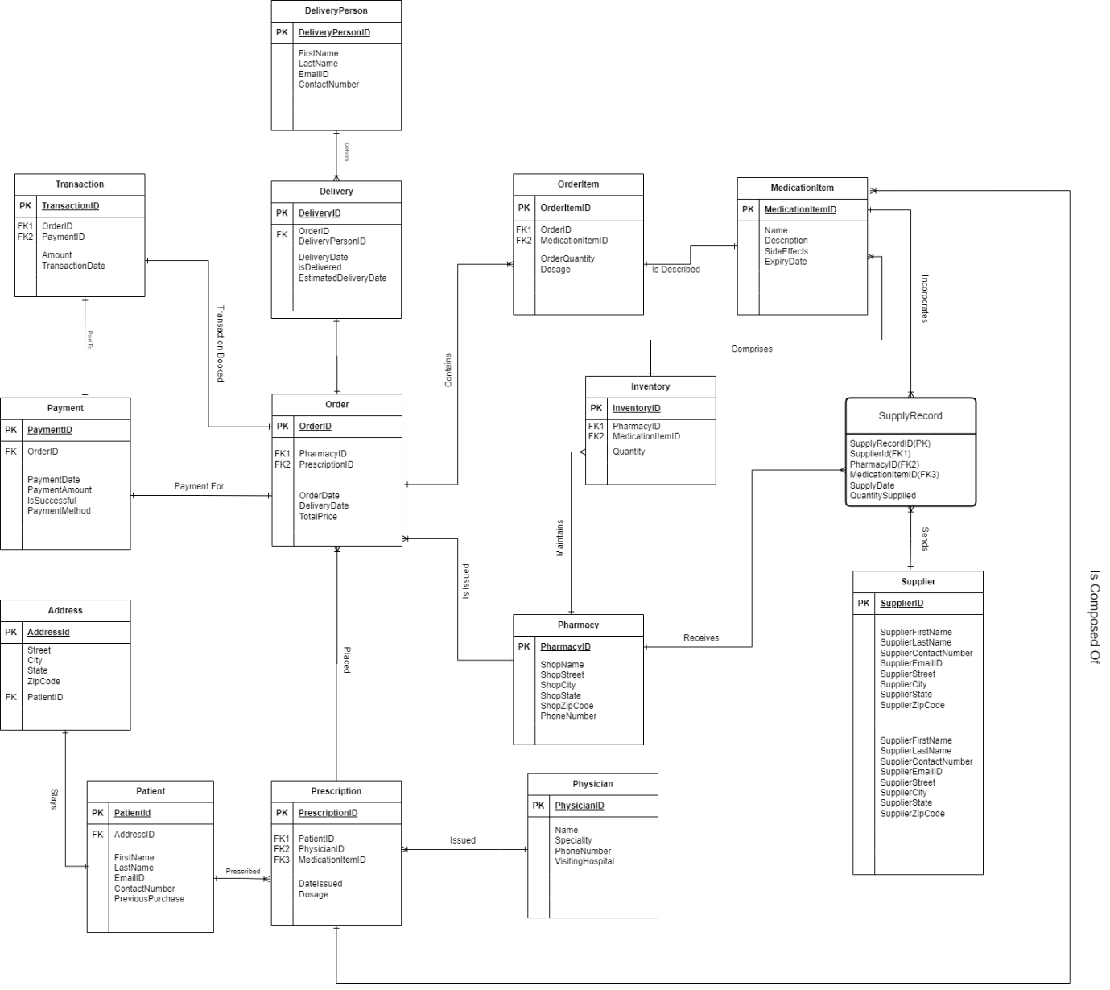

Please find below the updated entities description.

1. **Patient Entity**: Central to the system, it holds personal and contact information of the patients. It is linked to the Address entity for address details and to the Prescription entity, indicating that a patient can have multiple prescriptions.
2. **Prescription Entity**: Contains details about the prescriptions issued by physicians to patients. It has a many-to-one relationship with the Patient entity and a many-to-one relationship with the Physician entity, showing that multiple prescriptions can be associated with a single patient and a single physician.
3. **Physician Entity**: Contains details about the prescriptions issued by physicians to patients. It has a many-to-one relationship with the Patient entity and a many-to-one relationship with the Physician entity, showing that multiple prescriptions can be associated with a single patient and a single physician.
4. **Pharmacy Entity**: Contains details about pharmacies, including contact information. It is linked to the Inventory entity, showing that each pharmacy has an inventory of medications.
5. **Order Entity**: Represents the orders placed by patients, which are linked to prescriptions. It has a one-to-one relationship with the Prescription entity and a one-to-many relationship with the OrderItem entity, indicating that each order can contain multiple items
6. **OrderItem Entity**:It is a part of the order line and it details the specific items within an order, including the medication and quantity. It is linked to the MedicationItem entity, which contains information about each medication.
7. **MedicationItem Entity**: Holds information about the medications available, including description and side effects. It is linked to the Inventory entity, showing that medications are part of the pharmacy's inventory.
8. **Inventory Entity**: Tracks the stock levels of medications in each pharmacy. It is related to the SupplyRecord entity, which logs the supply transactions between suppliers and pharmacies.
9. **SupplyRecord Entity**: Records the details of medication supplies from suppliers to pharmacies, including the quantity supplied.
10. **Supplier Entity**: Contains information about the suppliers who provide medications to pharmacies. It is linked to the SupplyRecord entity, indicating that suppliers can have multiple supply records.
11. **Payment Entity** Represents the payment transactions for orders, including the payment method and status. It is linked to the Order entity, showing that each order has an associated payment.
12. **Transaction Entity**: Logs financial transactions, potentially linked to payments and orders, indicating the financial activity related to each order.
13. **Delivery Entity**: Contains details about the delivery of orders, including the delivery status and dates. It is linked to the DeliveryPerson entity, showing who is responsible for the delivery of each order.
14. **DeliveryPerson Entity**: Stores information about the individuals responsible for delivering orders to patients.
15. **Address Entity**: Holds address details for patients, which is linked to the Patient entity, indicating that each patient has an associated address.